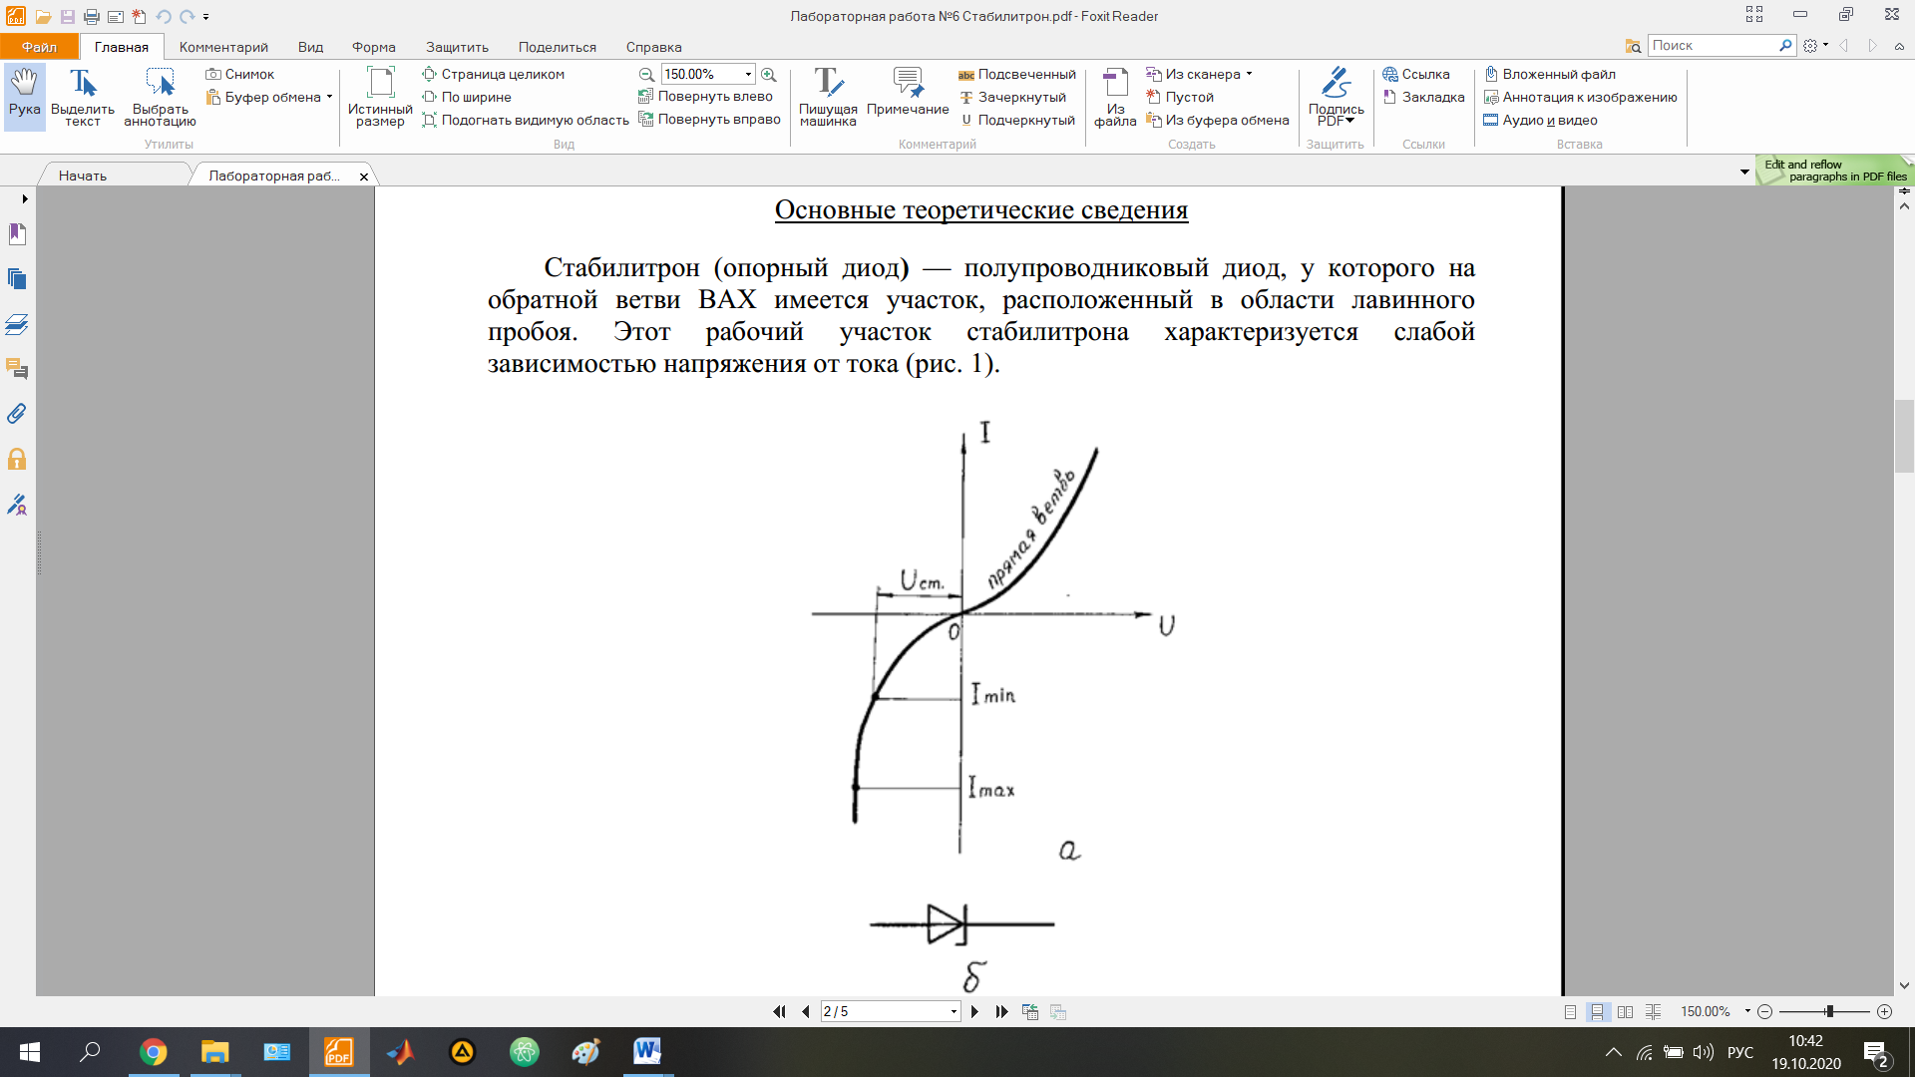

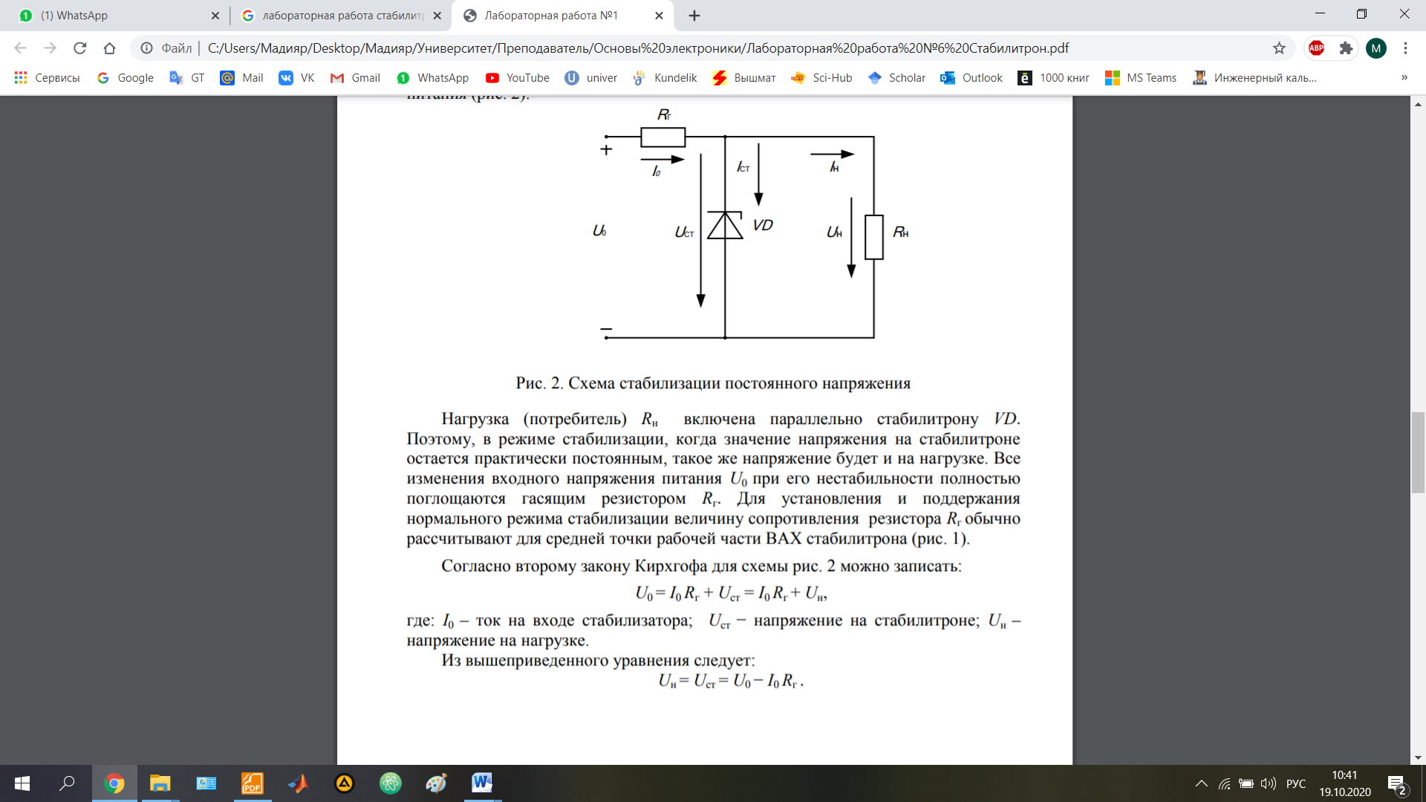

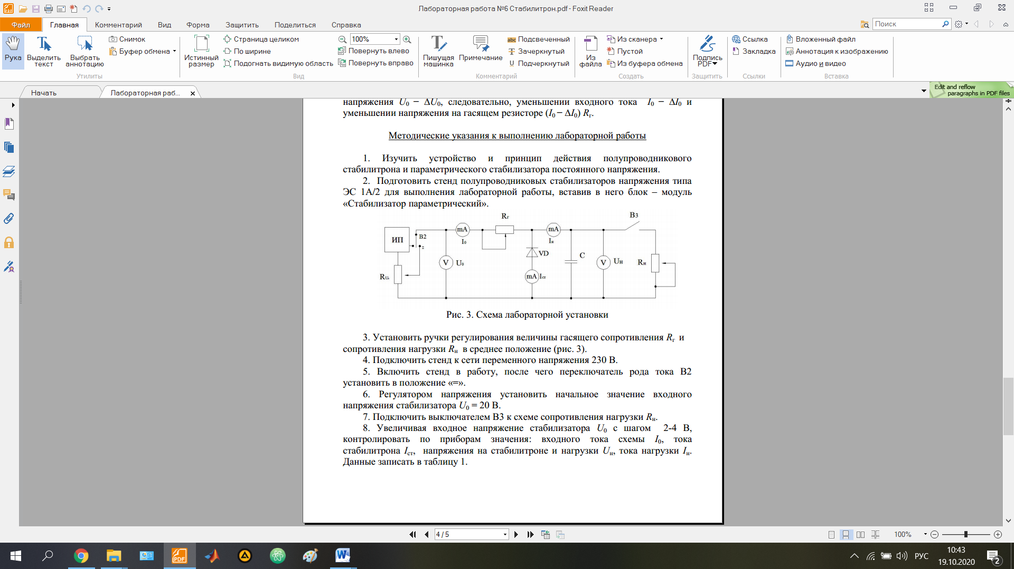

|  |  |  |  |  |  |
| --- | --- | --- | --- | --- | --- |
| № | U0, V | I0, mA | Iст, mА | Uн =Uст | Iн, mA |
| 1 |  |  |  |  |  |
| 2 |  |  |  |  |  |
| … |  |  |  |  |  |
| 9 |  |  |  |  |  |
| 10 |  |  |  |  |  |